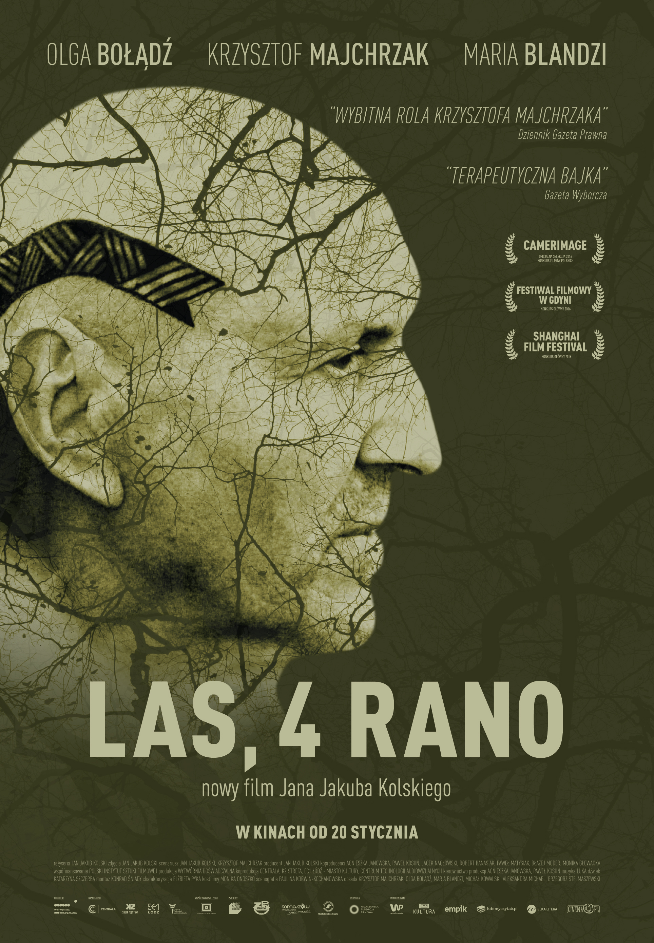

Forest, 4 am.
A Film by Jan Jakub Kolski

ABOUT:
FORST is a wealthy, well-organized man. When we first meet him, he seems to be the king of the world . One day, he quits his job in the corporation, where he is as a vice-president. The damage he leaves behind makes his return very unlikely.
Forest, 4 am, several years later. A half-savage, unkempt and dirty hobo is setting up snares. You can just barely recognize Forst in him. He lives in the woods in peace with nature, in a shelter he built himself. His only companion is a three-legged dog. His food is mostly animals he hunts for.
One day, a 13 year old girl named JADZIA appears at his doorstep. Forst has to make changes in his life once again...

PRESS QUOTES:
- Therapeutic fairy tale
Tadeusz Sobolewski, „Gazeta Wyborcza”

- Outstanding role by Krzysztof Majchrzak
Piotr Czerkawski, „Dziennik Gazeta Prawna”

- (…) it’s a highly personal work, yet subtle and free from any pretentiousness (…)
The pain, fear but also hope that we need to fight for every day, comes from the phenomenon that is Krzysztof Majrzchak.
Łukasz Adamski, „wPolityce”

- This film has a potential to become a therapeutic work.
Tomasz Błoński, „Wprost”

- Jan Jakub Kolski really exposed himself. “Forest, 4 am” is the most intimate film by this director of “Pornography” and on the screen he capturer authenticity, honesty and real emotions. A whole sea of emotions (…)
This film captures truth, pain but also hope for a better future (…)
Jan Jakub Kolski is seductively captured the main characters and the nature surrounding them.
Krzysztof Polaski, „Telemagazyn”

WORD FROM THE AUTHORS:
Krzysztof appeared on the screen with everything he is. He is both harsh and gentle, you can be afraid of him, be moved by him and be in awe with him. He really gives you the whole possible range of emotions. His on-screen partner here is Marysia Blandzi – at a first glance fragile person, incredibly talented. In a very emotional and beautiful role we also see Olga Bołądź, who in one moment is so delicate that almost transparent and seconds later becomes strong and assertive, fighting for her future. The three of them, like constellation on the screen, bring all the emotions. All you need to do is go to the cinema and feel that what happens between them and what it is, is truly moving.
Jan Jakub Kolski

I definitely approached this with an extreme honesty, because I won’t do things if I can’t fall in love with them. Really we didn’t leave the forest at all and with its beauty the forest was our saviour. We felts privileged to be surrounded by the beauty of nature around us. Through the struggle we encountered and the heroism that everyone presented in this process of filmmaking we created a phenomenal community.
Krzysztof Majchrzak

Like in all the other beloved works of Jan Jakub Kolski, here again you can find the most beautiful Polish nature captured on screen. Even though this film is about a very difficult topic, about a loss and how to cope with that, it really is beautiful.
Olga Bołądź
We have animals, changing seasons, trees, there is rain and sunny days, it’s hot and cold. It would be a waste to pretend that all these things don’t add up to this thing we call life. If you want to capture real life on the big screen you should not forget about nature and all its components.
Jan Jakub Kolski

CAST AND CREW:

Directed by: Jan Jakub Kolski
Script based on a novel “Forest, 4 am”: Jan Jakub Kolski, Krzysztof Majchrzak
DoP: Jan Jakub Kolski
Music by: Luka
Sound by: Katarzyna Szczerba
Editing by: Konrad Śniady
Make-up by: Elżbieta Pyka
Costume designer: Monika Onoszko
Production designer: Paulina Korwin- Kochanowska
Cast: Krzysztof Majchrzak, Olga Bołądź, Marysia Blandzi and Michał Kowalski, Aleksandra Michael, Grzegorz Stelmaszewski
Produced by: Jan Jakub Kolski
Production: Wytwórnia Doświadczalna
Co-producers: Agnieszka Janowska, Paweł Kosuń,
Jacek Nagłowski, Robert Banasiak,
Paweł Matysiak, Błażej Modras, Monika Głowacka
Co-production: Centrala, K2, Audiovisual Technology Centre, EC1 Łodź – City of Culture, City of Łódź
Production manager: Agnieszka Janowska, Paweł Kosuń
Genre: feature film, drama
Premiere: 15.06.2016
Shanghai International Film Festival
Distribution: Wrocławska Fundacja Filmowa
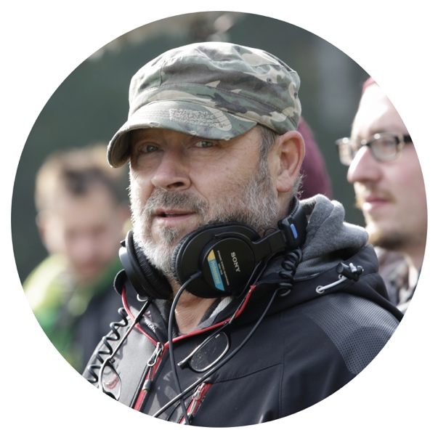
DIRECTOR

Jan Jakub Kolski
Director, scriptwriter, director of photography, writer, academic teacher, member of Polish and European Film Academy. In his professional career he made over twenty documentary films, sixteen feature films and wrote eight novels. Numerous of times his films have been awarded at festivals in Cannes, Venice, Berlin, Tokyo, Moscow and Montreal. He comes from a family with strong connections to the film industry.

CAST
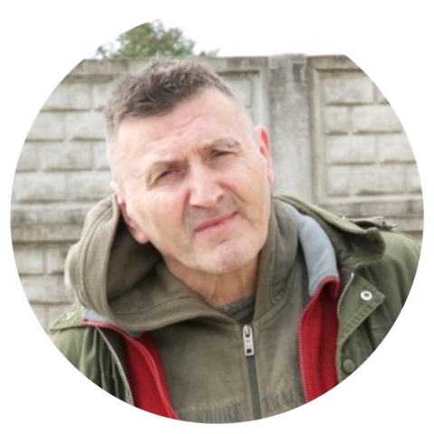
Krzysztof Majchrzak
Film and theatre actor and musician. One of the most recognisable character actor in Polish cinema. He is a lecturer at Warsaw Theatre Academy. At the beginning of his career he worked with the National Theatre. For many years a member of Powszechny Theatre in Warsaw. Since 1991 he has been an actor in the Studio Theatre in Warsaw. He stared in over 30 films and dozens of TV theatre productions.

Selected filmography:
Inland Empire – dir. D. Lynch
Pornography – dir. J. J. Kolski
Quo Vadis – dir. J. Kawalerowicz
Historia kina w Popielawach – dir. J. J. Kolski
Axiliad – dir. W. Leszczyński
Yesterday – dir. R. Piwowarski
Konopielka - dir. W. Leszczyński
Promised Land– dir. A. Wajda

Olga Bołądź
Film, theatre and TV actress. Graduate of the Academy of the Dramatic Arts in Cracow, received a scholarship of Institut del Teatro in Barcelona. She performed in National Stary Theatre and Polonia Theatre in Warsaw. So far she has stared in over 20 films and 11 TV series such as “Days of Honour”, „Special forces” and „On the Edge”.

Selected filmography:
Good morning, I love you – dir. R. Zatorski
Special forces– dir. P. Vega
Flying Pigs- dir. A. Kazejak-Dawid
The Girl from the Wardrobe– dir. B. Kox

Marysia Blandzi
A singer, a ballet dancer, clarinet player, karate kyokushin master, actress. Her debut was in “the Heart and the Sweetheart” by Jan Jakub Kolski. For her portrayal of Maszeńka she received a jury special award at Film Acting Festival in Wroclaw and an audience award at International Festival of Film Art in Września. Critics consider her one of the most promising children debut in Polish cinematography in recent years.

CO-PRODUCERS:
CENTRALA focuses on producing documentary and fiction films by young filmmakers. Our team consists of people with from diverse work experience: Jacek Naglowski, Agnieszka Janowska, Pawel Kosun – the founders, owners and producers.
Up until this point Centrala has produced six fictions and twelve documentaries that have been shown at dozens of international festivals such as Cannes, Vision du Reel, Cinema du Reel, Planete +Doc, Hot Docs, Cracow Film Festival, Warsaw Film Festival and others. Films we produced have received 44 awards in many categories including 10 Grand Prix and 6 Best Picture awards. Our film Gugara was purchased by Centre Pompidou in Paris and included in their collection. Currently we have four films at the post-production level and five in development.
We have been working together since 2004.

Audiovisual Technology Center is a state-owned cultural institution supervised by the Ministry of Culture and National Heritage. It was created in November 2011 as a result of the transformation of the Wroclaw Feature Film Studio (WFF Wroclaw) and is currently the successor and keeper of the years-long, rich tradition of the WFF.
Audiovisual Technology Center is active in the field of promoting and development of modern multimedia technologies, as well as education (workshops, courses, seminars and lectures) and spreading culture (festivals, meetings, showcases). Film studios and professional technical support allow production and co-production of movies. An array of advanced technology, which is at the institution’s disposal, and a qualified staff of specialists allow, among others, creation of visual special effects for use in cinema and media, including television.
One of institution’s tasks is also implementing work proficiency in the area of visual and audiovisual art., special effects and electronic post-processing. The institution also conducts research with the aim of improving the technologies used in moviemaking.

PRODUCER
Wytwórnia Doświadczalna
Jan Jakub Kolski

CO-PRODUCERS
Centrala / centralafilm.pl /
K2 / k2strefa.pl/
Audiovisual Technology Centre / filmstudioceta.pl /
EC1 Łódź – City of Culture /ec1lodz.pl/
City of Łódź

DISTRIBUTION
Wrocławska Fundacja Filmowa / wrocff.com.pl

Film co-financed by the Polish Film Institute

Film created with a help of:

CONTACT DETAILS

www.las4rano.pl
janowska@centralafilm.pl
kosun@centralafilm.pl

